## Problem 4 – Responsive

You are given an unresponsive Web site (**HTML** + images). The website is as wide as the screen and has no whitespaces from the left and the right side (see Figure 1). Your task is to **make the site responsive**. The site layout should change according to the browser viewport / screen size.

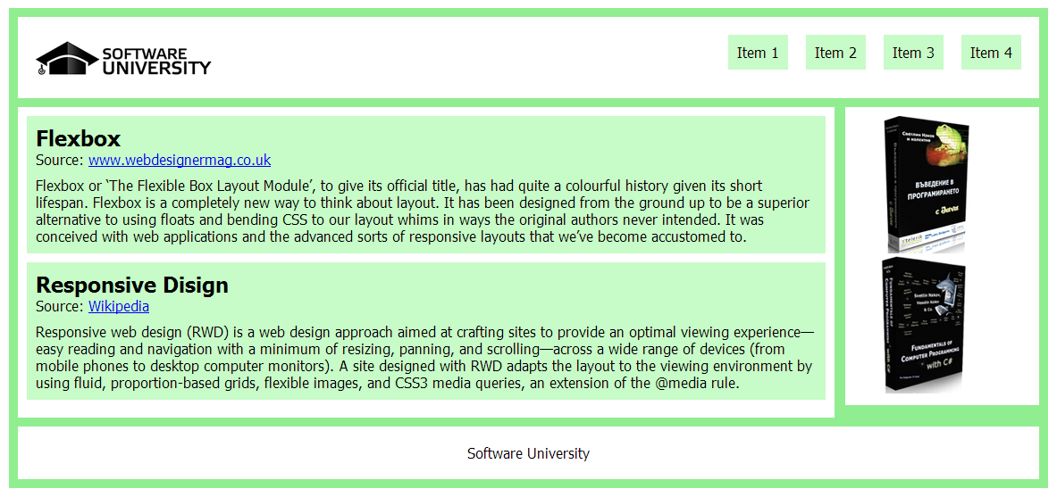

Figure 1

1. From **480px to 780px** – The sidebar moves to the bottom of the page and images in it are side by side. The menu falls below the logo, the menu and the logo are centered (see Figure 2).

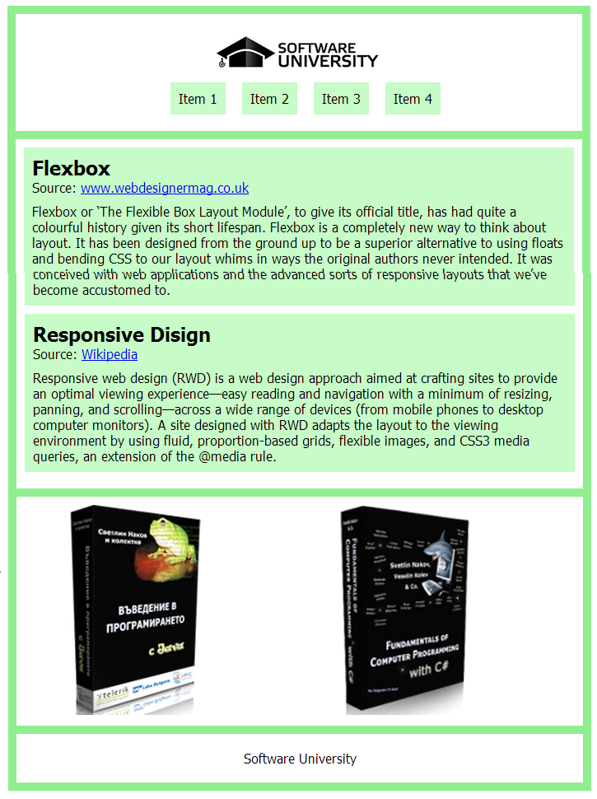 

Figure 3

Figure 2

1. **Under 480px** – The images in the side bar are on different rows. The menu changes again (see Figure 3).

### Input

You are given the unresponsive site as HTML + images.

### Output

The output should be valid HTML5 + CSS3 + images that implement the above responsive site.

### Constraints

* You are free to change the HTML, as well as use external frameworks like Bootstrap.
* Pixel-perfect implementation is not required.